What to do with Unused Medicine?
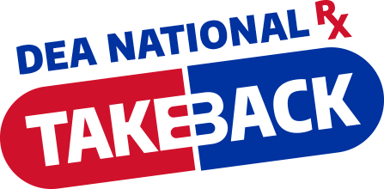
Keeping unused or expired prescription medicines in your home can be dangerous! Prevent prescription drugs from getting into the wrong hands.
Rid your home of unwanted/unused prescriptions.
Drop them off for safe disposal during
National Prescription Drug Take-Back Day
October 25, 2024
10 a.m. – 2 p.m.
Sponsored by:
Taliaferro County Sheriff's Office & Family Connection
Drop off location:
Dollar General
494 Broad Street
Crawfordville, Georgia 30631

The service is free and anonymous, no questions asked.
Site cannot accept liquids or needles or sharps, only pills or patches
Visit www.dea.gov for more info.

